Refined Design Co.

**Introduction**

My main objective with the Refined Design Co. website was simplicity. There are many websites that are out there that try to make themselves look better then the rest, through the use of animations/3D effects (shadowing) and messy content. When it comes to websites, I feel that the content within the website needs to be delivered to the reader with little effort of the readers behalf, i.e. the content needs to be easy to find and easy to read.

**Structure of the website**

The structure of Refined Designs Co. is fairly generic, in that the main page is the homepage, which is then linked to 4 sub-pages. Below is a diagram of how this is mapped out.

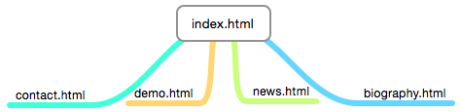The website consists of 4 sub pages, all of which I will talk about in more detail later on. Contact.html, there are multiple forms implemented into this page, so that user can give information to the company, which will then be sent to the company’s email. Demo.html has an interact game which uses HTML 5 Canvas and JavaScript. News.html has a mock news article that I wrote up and follows a standard news page layout. I used inspiration from wired.co.uk for this page. Biography.html is a page that has a small description of myself being the creator of the company.

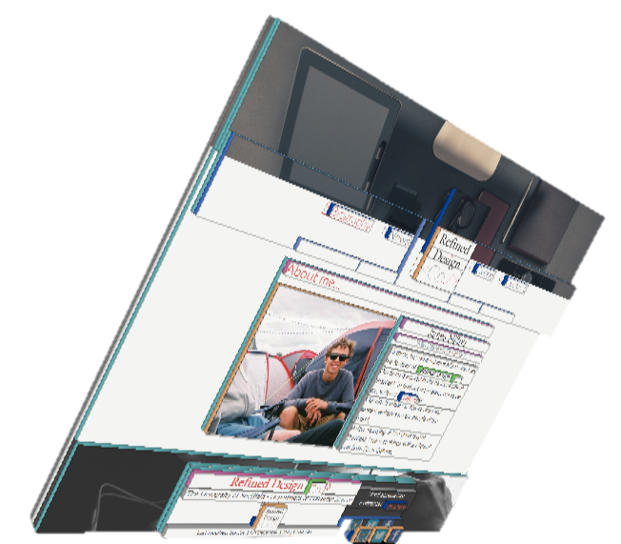All of these pages are linked to one and other, so that if I was on news.html, I can access demo.html by using the navigation bar.

**Navigation bar**

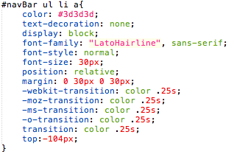The navigation bar I have created is a simple way to get to whatever page you want, regardless of what page you are currently on. It features CSS 3 fade in and out effects, to make the nav bar look and feel more of a higher quality. An example of my code can be seen here.

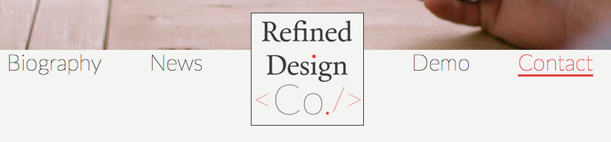The navigation bar features 5 links. The homepage is unique in that instead of just having a standard text link, it features the company’s logo, and when you hover over it, it slowly fades away and the word ‘home’ is highlighted.

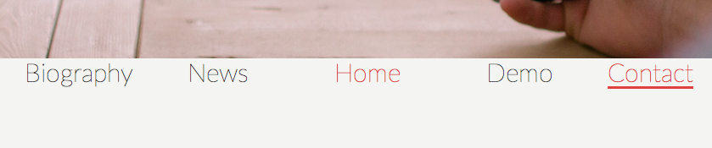Also, when you highlight over the text link, an underline appears, but it draws it self on through an animation, which looks quite professional.

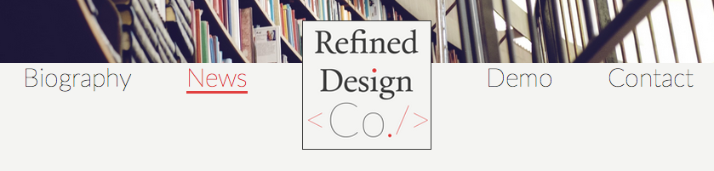Each page has it’s own personal header image which have a free license agreement, which fits any resolution screen. Each picture is suited for each page. For example, the contact page features a man holding an iPhone, which is appropriate as a phone is what you use as a means of contact.

Another professional element of the website is the use of parallax effect scrolling with the header. When the user scrolls downwards, the header image stays still, whilst the rest of the context scrolls up or down. This was achieved through the use of z-index in CSS.

The logo itself featured below is clean and simplistic. Made in Photoshop CS6, this logo represents the simplicity that the company aims to achieve, with an unique edge, with incorporating the **‘</>’**

that is commonly associated with website development.

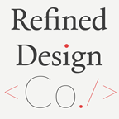

The logo is consistent with the websites house design with the use of the house font and colour scheme, those of which I will talk about in more detail later.

**The footer**

The footer which you can see below is consistent across every page on the website.

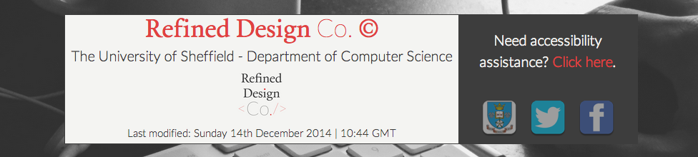It features a background image of a mouse and keyboard in operation. The main content of the footer consists of the name of the company, with a copyright symbol, to prevent any copyright infringements. Additionally, is has an image of the logo of the company which is linked to the homepage when clicked on. At the very bottom, it shows when the website was last modified as well, so the user knows whether it is an actively updated website as well.

On the right hand side shows a clear link intended for those who require accessibility help, which I will be talking about in more detail later. Also below is 3 external links that take you to the University of Sheffield website, twitter page and Facebook page. These 3 images initially have an opacity of 0.5, but when you hover over them, they fade-in to their full opacity.

**The website’s house design scheme**

Refined Designs Co. website is consistent in its use of colours and fonts. The main two fonts are Calendas Plus and Lato. These fonts are implemented into the CSS like so… I have implemented a lot of different formats of fonts so that the fonts work consistently across all browsers.

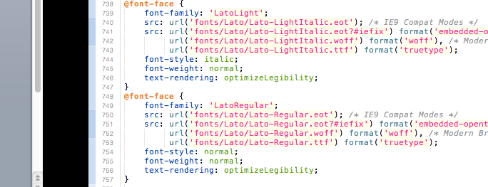In terms of colour use, I used a colour board of 4 main colours, all of which have their own function.

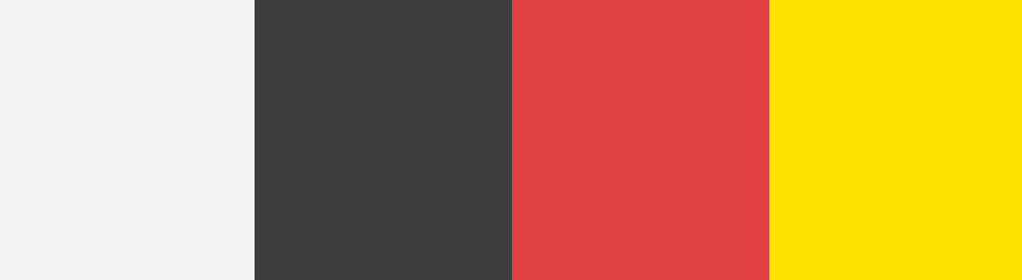

#F4F4F2 #3D3D3D #E14040 #FEE202

Firstly, #F4F4F2 is the colour used for the body background. I like this colour because I wanted the background to be sleek and not too intrusive, but I though plain white would be too boring, which is why I went for this off-white alternative.

#3D3D3D is the colour used for all text, which includes all <p> elements, and is used in some other elements as well, such as borders. Once again, it introduces a subtle difference to the common use of black text, but is not to bold and intrusive for the reader to look at.

#E14040 is the colour used on <a> links and such as borders and underlining text decoration as well. It goes in sync with the use of the same red in the logo, and is bold enough to signify to the user that if a piece of text has that colour on it, it is a link that will take them somewhere significant.

#FEE202 is the secondary colour, and used really as a back up if none of the other colours are appropriate, because they are already in use. For example, you will find this colour in <a> links as well, and that is pretty much it. It’s a bold colour, so it is easy for the reader to find amongst a lot of text.

***Website pages* – Home page**

The homepage is simple and effective. The text I used is standard filler language, which incorporates a selection of internal links which take you to the subpages of the website, to demonstrate the use of the slow fade in out and out effect in CSS and the use of colour in the links.

The load up time of the home page is very fast due to its simplicity. The main function of the website it to slowly introduce the user to the website, by providing a small amount of information, the logo, the company name and links to allow the user to find out more information if they so choose too.

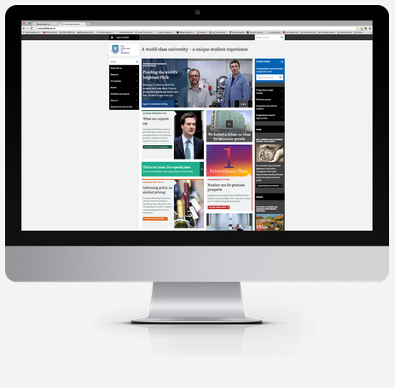I chose to create an image of an iMac displaying an image of the University of Sheffield’s website, to potentially give the effect that they were a previous client of this company.

All of the images on the website have been optimized, so that they are a small size, but still uphold the same quality, but load faster on the webpage.

***Website pages* – Demo page**

The demo pages main attraction is the game Internet Explorer Hunter. The game was inspired by the fact that Internet explorer is always hard to develop website for, as it does not behave in the same way as other browsers. There are 3 main elements, the University of Sheffield Superman, the Internet Explorer enemy and the map of university campus.

These images I made Photoshop CS6, and had the appropriate licenses to allow me to edit them.

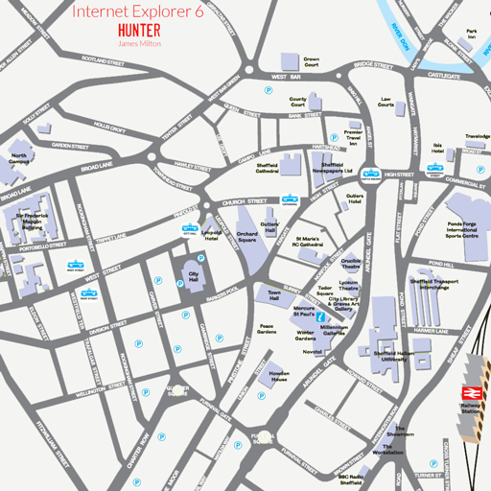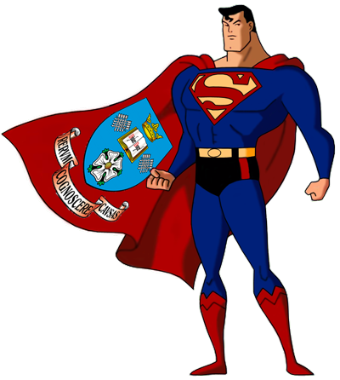

The aim of the game is destroy as many Internet explorers in the 1-minute time limit. Once the time timer gets to 1 minute, you can reset the game and try and beat your high score.

***Website pages* – Contact page**

The contact page allows the user to provide the necessary information needed to get a quote for the website they desire. It includes the necessary information, such as first name, second name, email address and the information on what kind of website you would like in the comments section. There is also optional forms to fill in, such as the users phone number and their current website if they do so have one.

Some of the forms have an auto complete function, whereby when you press on the website form, it will automatically delete what is in the form already, and replace it with http://, to then allow you to put in the rest of the website address.

Additionally on the contact page is where the fictitious company is based. I put down an example address of the students union for the University of Sheffield. It also features an interactive map of the ‘head quarters’ provided by an API by Google.

***Website pages* – News page**

For this page, I wrote up a story on the new release of the limited edition of the PS4. Some of the story content comes from wired.co.uk.

A news page needs to be clear for the reader. The most important of news articles needs to stand out from the rest, therefore it has o be bold and large.

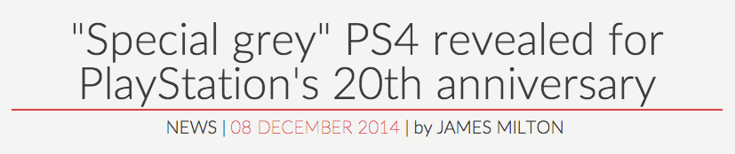

I feel that the news title for my news article works because al the relevant information is there. It has a bold title which can be read easily and found easily with its red underlining. Also, it provides the information regarding when it was written, and who by.

One particular element that makes this page unique is the styling of quotes. I think that quotes need to stand out as that is raw news coming from someone where the information is most relevant.

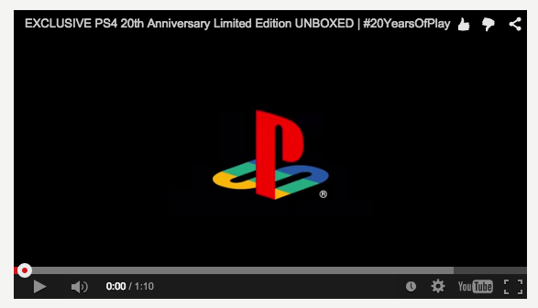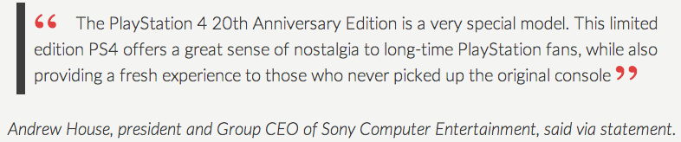

Also on the page, I made use of the API’s that both YouTube and Twitter provide. With Youtube, I have implemented a video provided by the PlayStation company of the PS4.

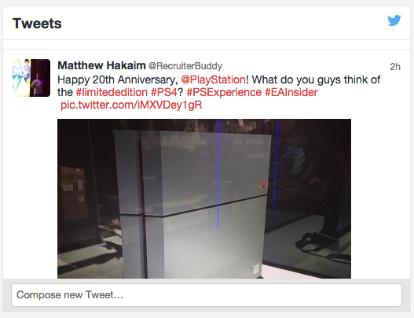

Additionally, there is a live Twitter stream containing all popular tweets regarding the news PS4, to allow the user to look beyond factual news and see what the community thinks about the news agenda.

***Website pages* – Biography page**

The biography page is the simplest page. It features a picture as myself, modeling as the founder of the company, with a brief description of the company and myself, whilst incorporating a few different text-formatting styles.

***Website pages* – Accessibility page**

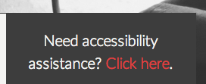The accessibility page isn’t a page as such, but more an overlay/light box. When the user clicks the ‘Click here’ link, or simple uses the access key ‘a’, this overlay below comes up, which provides the reader with accessibility information.

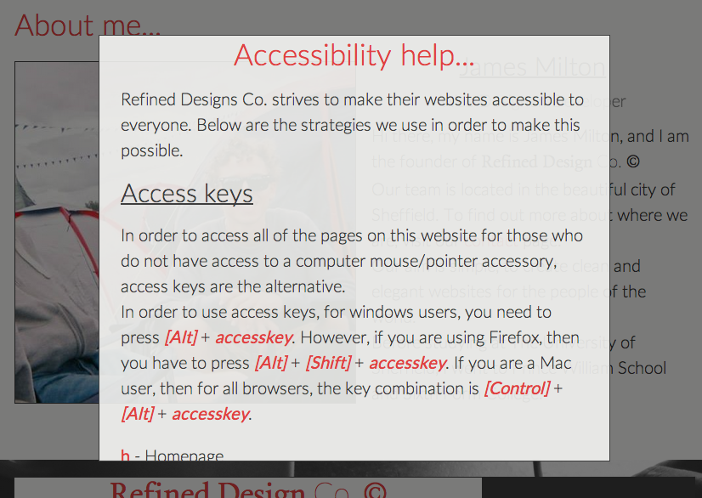

Macintosh HD:Users:James:Dropbox:Public:refineddesign.co:images:select.pngThe window scrolls up and down, and provides user on how to use the access keys, what alt tags are and how they’re used. Information on the text-selecting feature I implemented into the CSS, where when you select text, the background and text changes colour.

The accessibility page can be accessed on all pages, and it works by using z-index in CSS. The accessibility overlay also causes the backdrop of the page to darken, to give the effect that it is shadowed by the overlay. In order to exit the accessibility overlay, you simply need to click anywhere on the screen.

**Data requirements**

A number method of methods have been put into place in order to make the website run more efficiently and quickly.

Firstly I optimized all of the images in the website using <https://kraken.io> software. Optimizing the images allowed me to reduce the size of the images so that they load quicker, but still maintain the same quality and resolution.

Secondly, using Meyer’s reset, the goal of a reset style sheet is to reduce browser inconsistencies in things like default line heights, margins and font sizes of headings, and so on in all browsers, therefore making my website look consistent in style across all browsers.

Also using HTML5 Shiv, The HTML5 Shiv enables use of HTML5 sectioning elements in legacy Internet Explorer and provides basic HTML5 styling for Internet Explorer 6-9, Safari 4.x (and iPhone 3.x), and Firefox 3.x which too means that the website looks consistent across all browsers.

Additionally, to make maintenance easier, all of the CSS can be found in one CSS file, default.css, and all of the JavaScript can be found in one file, main.js. This means all the code can be found in one place, and I have used comments to order all of the code, so finding a specific bit of code can be done easily.

**Debugging**

The method I used to see whether my website worked on all browsers and all sizes of resolution was using browserstack.com. It allows you to see you website on other platforms. The only bug that has not been resolved is that on IE6, the header image does not appear.